





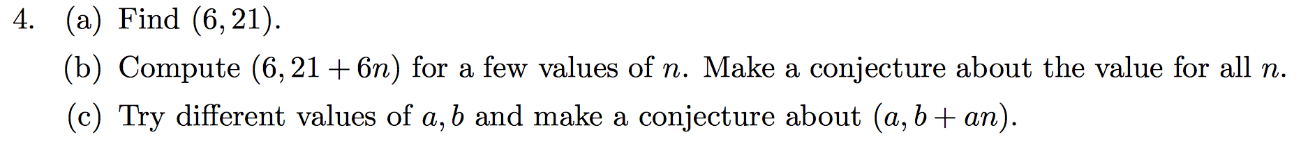

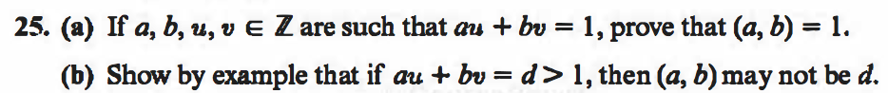

/Users/jacobshiohira/Desktop/Screen Shot 2017-01-26 at 10.31.50 AM.png